Verification of Node Voltage Method using PSPICE

LAB # 7



Spring 2022

CIRCUIT AND SYSTEMS 1 LAB

Submitted by: MUHAMMAD SADEEQ

Registration No.: 21PWCSE2028

Section: C

"On my honor, as student of University of Engineering and Technology, I have neither given nor received unauthorized assistance on this academic work.'

Submitted to:

Engr. Faiz Ullah

(June 2, 2022)

Department of Computer Systems Engineering University of Engineering and Technology, Peshawar

**Experiment # 7**

Verification of Node Voltage Method using PSPICE

**Objectives:**

* How to calculate node voltages of a circuit.

**Node voltage analysis:**

In electric circuits analysis, nodal analysis, node-voltage analysis, or the branch current method determines the voltage ([potential difference](https://en.wikipedia.org/wiki/Potential_difference)) between [nodes](https://en.wikipedia.org/wiki/Node_(circuits)) (points where elements or branches connect) in an [electrical circuit](https://en.wikipedia.org/wiki/Electrical_circuit) in terms of the branch currents.

**Nodes:**

A node is the point of connection between two or more branches. A node is usually indicated by a dot in a circuit. If a short circuit (a connecting wire) connects two nodes, the two nodes constitute a single node.

**How to apply KCL equations at each node:**

1. Note all connected wire segments in the circuit. These are the nodes of nodal analysis.
2. Select one node as the [ground](https://en.wikipedia.org/wiki/Ground_(electricity)) reference. The choice does not affect the element voltages (but it does affect the nodal voltages) and is just a matter of convention. Choosing the node with the most connections can simplify the analysis. For a circuit of N nodes, the number of nodal equations is N−1.
3. Assign a variable for each node whose voltage is unknown. If the voltage is already known, it is not necessary to assign a variable.
4. For each unknown voltage, form an equation based on Kirchhoff's Current Law (i.e. add together all currents leaving the node and mark the sum equal to zero). The current between two nodes is equal to the voltage of the node where the current exits minus the voltage of the node where the current enters the node, both divided by the resistance between the two nodes.
5. If there are voltage sources between two unknown voltages, join the two nodes as a [super-node](https://en.wikipedia.org/wiki/Supernode_(circuit)). The currents of the two nodes are combined in a single equation, and a new equation for the voltages is formed.
6. Solve the system of [simultaneous equations](https://en.wikipedia.org/wiki/Simultaneous_equations) for each unknown voltage.

**Diagram:**

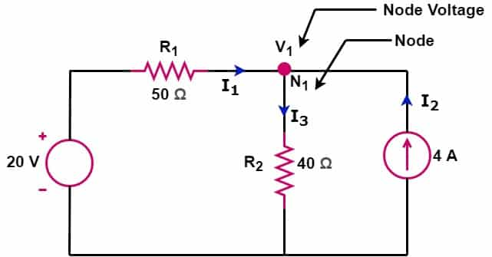

**Example:**

Suppose N1 is maximun volatge source

I1 + i3 – i2 =0

V1= 97 volts

**PSPICE Simulator:**

PSPICE is a computer-aided simulation program that enables you to design a circuit and then simulate the design on a computer. As this is one of its main purposes, it is used extensively by electronic design engineers for building a circuit and then testing out how that circuit will simulate.

**Apparatus:**

* Computer with PSPICE installed

**Procedure:**

1. Open schematic program of PSpice
2. Click on the “Get New Part” button on the toolbar
3. Type ‘r’ in the search bar and place the eight resistors on the white sheet
4. Type ‘vdc’ in the search bar and place two of them on the white sheet
5. Type ‘gnd-earth’ and place it on the white sheet
6. Now arrange these components on the white sheet according to the circuit diagram as following
7. After arranging click on simulate button and the following results are generated

**Diagram:**

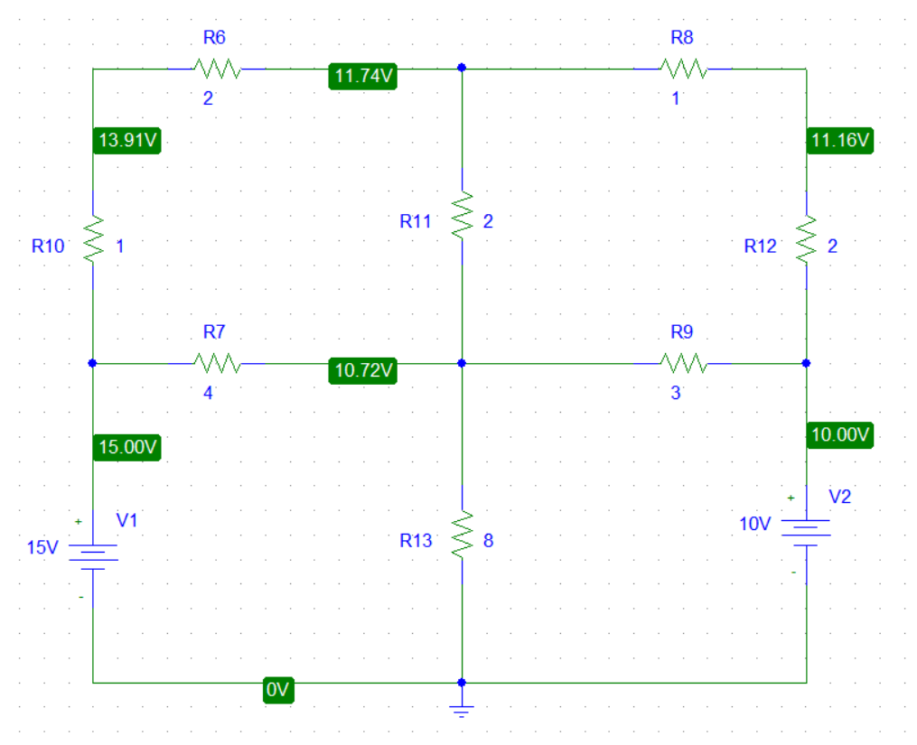

**OBSERVATION:**

**Pspice:**

|  |  |
| --- | --- |
| V1(volts) | V2(volts) |
| 11.74 | 10.72 |

**Calculation:**

Suppose V1 is the maximum voltage source then

$$\frac{V1-15}{3}+\frac{V1-10}{3}+\frac{V1-V2}{2}=0$$

$$7V1-3V2-50=0$$

Suppose V2 is the maximum voltage source then

$$\frac{V2-15}{4}+\frac{V2-V1}{2}+\frac{V2-10}{3}+\frac{V2-0}{8}=0$$

$-12V1+29V2-170=0$

Solving both equations I got the following result

**Calculated:**

|  |  |
| --- | --- |
| V1(volts) | V2(volts) |
| 11.7365 | 10.7185 |

**Conclusion:**

Form the experiment I concluded that the node voltage method is 100% correct way to find the voltages in the given circuit because I verify it by Pspice and it correct.